Cascading Style Sheet - 3

Version: 1.0

Document Control

Reference No: | IRL-Enterprise Mobility Tech Labs/Cascading Style Sheet-3
Security Classification: | Confidential
Issue Date: | 28/01/2011
Author (s): | Name |  | Title
Author (s): | Pritesh Jawale |  | Senior Software Engineer
Reviewer (s): | Name |  | Title
Distribution: | Name |  | Location
Document History: | Date | Revision | Change
Document History: | 31/01/2011 | 1.0

Introduction:
Cascading Style Sheet 3 is nothing but the advanced version of CSS2. It is the latest version of CSS family and is used to control the style and layout of the web pages. CSS3 is completely backward compatible, so you will not have to change existing designs. Browsers will always support CSS2. This article will take you through the features that are supported or can be done using CSS3.

CSS3 Modules:
CSS3 is split up into "modules". The old specification has been split into smaller pieces, and new ones are also added.
Some of the most important CSS3 modules are:
- Selectors
- Box Model
- Backgrounds and Borders
- Text Effects
- 2D/3D Transformations
- Animations
- Multiple Column Layout

CSS3 Features/Modules:

Following are some listed features of CSS3

- Rounded Borders:

.border_rounded {
background-color: #ddccb5;
-moz-border-radius: 5px;
-webkit-border-radius: 5px;
border: 2px solid #897048;
padding: 10px;
width: 310px;
}

- Gradients:
Gradients are shown specifically for Mozilla browser. You can use the same for webkit or IE or Opera supported browsers. You need to replace moz by op or webkit.

.border_gradient {
border: 8px solid #000;
-moz-border-bottom-colors:#897048 #917953 #a18a66 #b6a488 #c5b59b #d4c5ae #e2d6c4 #eae1d2;
-moz-border-top-colors: #897048 #917953 #a18a66 #b6a488 #c5b59b #d4c5ae #e2d6c4 #eae1d2;
-moz-border-left-colors: #897048 #917953 #a18a66 #b6a488 #c5b59b #d4c5ae #e2d6c4 #eae1d2;
-moz-border-right-colors:#897048 #917953 #a18a66 #b6a488 #c5b59b #d4c5ae #e2d6c4 #eae1d2;
padding: 5px 5px 5px 15px;
width: 300px;
}



- Box Shadow:

.border_shadow {
-webkit-box-shadow: 10px 10px 5px #888;
padding: 5px 5px 5px 15px;
width: 300px;
}

- Border Images:
.border_image {
-webkit-border-image: url(border.png) 27 27 27 27 round round;
}
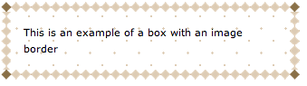
- Text Shadow:
.text_shadow {
color: #897048;
background-color: #fff;
text-shadow: 2px 2px 2px #ddccb5;
font-size: 15px;
}

- Word Wrapping:
.text_wrap {
word-wrap: break-word;
}
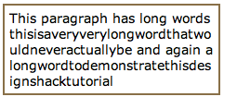
- Resizing:
This resizing feature is only supported in latest safari browsers as of now.
.ui_resizable {
padding: 20px;
border: 1px solid;
resize: both;
overflow: auto;
}

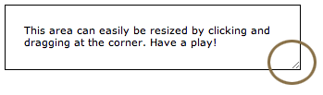
- Multicolumn Text:
At present, this feature is available in Firefox and Safari3. There are four properties which relate to the multiple column layouts in CSS3, allowing you to set the number of columns, width, gap between each column and a border between each:
- column-count
- column-width
- column-gap
- column-rule
.multiplecolumns {
-moz-column-width: 130px;;
-webkit-column-width: 130px;
-moz-column-gap: 20px;
-webkit-column-gap: 20px;
-moz-column-rule: 1px solid #ddccb5;
-webkit-column-rule: 1px solid #ddccb5;
}

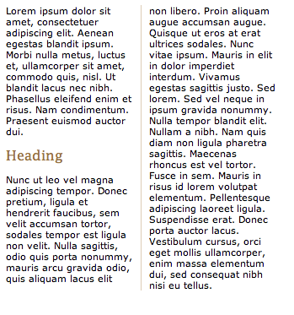

Note:
The CSS3 specification is still under development by W3C.
However, many of the new CSS3 properties have been implemented in modern browsers.

Browser Specific CSS3 Properties:
For Mozilla, Webkit, IE and Opera browser specific CSS3 properties please go through the following links.
For Mozilla
https://developer.mozilla.org/en/CSS_Reference/Mozilla_Extensions
For Webkit
http://qooxdoo.org/documentation/general/webkit_css_styles
For IE
http://blogs.msdn.com/b/ie/archive/2008/09/08/microsoft-css-vendor-extensions.aspx
For Opera
http://www.opera.com/docs/specs/presto27/css/o-vendor/

References:

- http://www.css3.info/preview/
- http://webdesign.about.com/od/css3/a/aa061206.htm
- http://designshack.co.uk/articles/introduction-to-css3-part-1-what-is-it
- http://www.w3schools.com/css3/css3_intro.asp

